NEW A 123 Dis-ME-Israel-Berekhat Ram, Israel, Late Acheulian Female Figurine

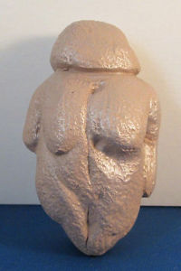 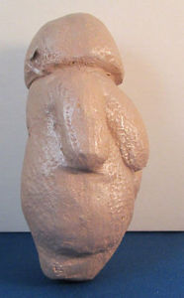 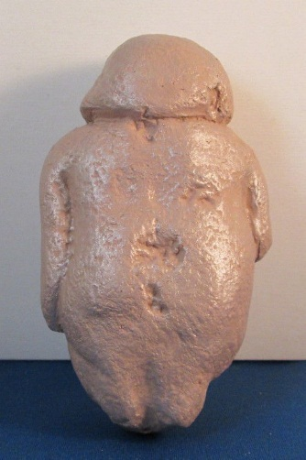 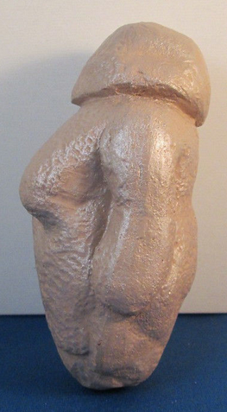

**Formal Label: Israel-**Berekhat Ram-Late Acheulian-Female Figurine

**Display Description:** This Late Acheulian figurine which bears microscopic traces of human modification predates the Willendorf figurine by at least 200,000 years and possibly up to 770,000 years.

**Accession Number: A 123.**

**LC Classification:** GN772.32.I75

**Date or Time Horizon:** 232,000-800-000 BP

**Geographical Area:** Israel, Berekhat Ram

**Cultural Affiliation:** Late Acheulian

**Medium:** original, basaltic scoria cobble.

**Dimensions: original, H** 4.75 in (12 cm)  
**Weight:**

**Provenance:** Hebrew University of Jerusalem's Institute of Archeology

**Condition:** Museum Replica-Ganges Clay and resin materials- This inexact replica is based on drawings and photographs provided by the Hebrew University of Jerusalem's Institute of Archaeology, where the original is housed.

**Discussion:** The similarities between the Willendorf figurine and the Late Acheulian figurine are remarkable. Both are distinctly female, great-breasted with featureless heads and distinct limbs. The carver of the Late Acheulian figurine adapted a cobble that already had Venus-like features to which the sculptor added grooves delineating the head and arms. Like the Willendorf figurine, the Late Acheulian figurine appears to have a vulva groove.

**References:**

Bednarik, R.G., 2006. Lecture No. 3. The evidence of paleoart. *Semiotics Institute Online: Cognition and symbolism in human evolution*.

d'Errico, F. and Nowell, A. 2000. A new look at the Berekhat Ram figurine: implications for the origins of symbolism. *Cambridge Archaeological Journal*, *10*(01): 123-167.

Goren-Inbar, N. 1986. A figurine from the Acheulian site of Berekhat Ram. *Mitekufat Haeven: Journal of the Israel Prehistoric Society/מתקופת האבן*, 7-12.

Hebrew University of Jerusalem's Institute of Archaeology.

Marshack, A. 1997. The Berekhat Ram figurine: a late Acheulian carving from the Middle East. *Antiquity*, *71*(272): 327-337.